Kanalweg 52
76149 Karlsruhe

Tel.: 0721 72752
Fax: 0721 7908806
Di-Fr 14-18 Uhr
Mi auch 10-12 Uhr
Sa 10-14 Uhr

Amerikanische

Bibliothek

Library Events June-July 2019

Regular Events ...

...for Kids

Are you from a bilingual family? Have you been living abroad and want to keep up your English? Have you moved to Karlsruhe and would like to meet other English speaking kids? Are you learning English and would like to practice it a bit more? Then join us for our fun storytimes:

Storytime in English!
Children ages 3-5 years are invited to our Storytime in English every 2nd and 4th Wednesday of the month at 16.00.

Stories for Kids ages 6 and up!
Join Claire, Heather or Julia twice a month on Fridays at 16.15! We meet and read stories in English together. Usually we do a craft, game or other fun activity afterwards. Please find the next dates below and if you would like to come, please call ahead and reserve a place (0721-72752)!

TeenTime
TeenTime is our group for everyone who is a teenager and not in elementary school anymore. Due to popular demand we meet now twice a month on a Friday from 16.15-17.15 to share book/DVD/computer game tips, try out science experiments, do fun crafts and other stuff - and here we want YOUR ideas!! ☺ One week will be led by one of our volunteers and the other week will be led by one of our teens. If you have an idea you would like to share with the group, be sure to sign up for a teen led TeenTime.
The next dates for Teentime are listed below – please call ahead and reserve a place so that we know how many of you to expect!

...for Adults

LitNight in English
Join us every 1st and 3rd Tuesday of the month from 19.30-21.00 at the American Library for reading and discussing literature in English. For more information call the American Library or simply stop by.

Poetry Please!
Poems in English read and discussed. Every 4th Tuesday of the month from 19.30-21.00 at the American Library. For more information call Tom (0721-3540477) or the American Library or simply stop by!

MovieTalk
Calling all cineastes: Join us every 2nd Wednesday of the month at 19.30 for MovieTalk ! Watch and discuss classics, should-be classics and films you might have missed. Each featured flick comes from the library’s own collection and will be shown in the original language (with English subtitles). Free of charge—donations cheerfully accepted. For more information please see separate leaflet.

June

Stories for Kids ages 6 and up:
Boa’s Bad Birthday
Friday, June 7th at 16.15
It was Boa’s birthday. It was going to be the best one ever. Or so he hoped. He invited his friends round. They would all bring him wonderful presents. Or would they?
Find out and join us for our storytime in English. Please call ahead and reserve a place. After the story, we’ll do a little craft.

TeenTime
Friday, June 7th at 16.15
In today’s TeenTime we’ll change the slightly boring corner where TeenTime takes place into a cool teen zone. So let’s get creative, make posters and decorate! Please call ahead and reserve a place!

MovieTalk
Erin Brockovich (Directed by Steven Soderbergh, 2000, 131 min., FSK: ab 6)
Wednesday, June 12th at 19.30
When a young, single mother gets a job as a legal clerk, she stumbles upon evidence that the drinking water in Hinkley, California is being contaminated, resulting in many serious illnesses. Her relentless investigation and brash, uncompromising style win the trust of the town’s residents, and her law firm launches one of the biggest class-action lawsuits in American history. Based on true events.
Starring Julia Roberts, Albert Finney, and David Brisbin.

TeenTime
Friday, June 14th at 16.15
Join Lesley, our library assistant in training, for a special TeenTime and create your own zine! A zine is a self-published book or magazine created by cutting and gluing images and text onto a masterflat which can then be photocopied and shared with others. There are no set rules for making a zine, it can be about any topic you choose. With Lesley, you'll learn how to create your own mini-zine and leave with either a finished product or work in progress that you can share with your family and friends! Please call ahead and reserve a place for our TeenTime or rather ZineTime ☺!

Stories for Kids ages 6 and up:
I want to win!
Friday, June 14th at 16.15
Together we’ll read the story “I want to win” about a little princess who loves to win - and hates to lose. Then we have fun trying out our new set of games in English such as Pictionary, Speak Out! and Taboo.
Please call ahead and reserve a place!

July

Stories for Kids ages 6 and up:
The Blind Hunter
Friday, July 5th at 16.15
The people in the village know Chirobo as a wise and kind man. Hardly anyone notices that he blind because he says he can “see with his ears, his nose and his skin”. Then, one day, Chirobo joins a stranger from another village on a hunting trip to the bush…
Today, our storytime takes us to Africa. If you’d like to join us, please call ahead and reserve a place.

TeenTime
Friday, July 5th at 16.15
TeenTime organized by YOU – the teens! ☺ Adopt a TeenTime and come up with some fun and or creative stuff to do with the other teens. Find out who’s doing the TeenTime today!

MovieTalk
Some Like It Hot (Directed by Billy Wilder, 1959; 121 minutes; FSK: ab 16)
Wednesday, July 10th at 19.30
This year marks the 60th anniversary of Billy Wilder’s iconic screwball comedy. Two hapless jazz musicians in Prohibition-era Chicago witness a gang murder and need to leave town in a hurry—which they manage to do by disguising themselves as women and joining an all-female band that is going on tour. As in Shakespeare’s comedies, cross-dressing leads to complicated emotional entanglements. Starring Marilyn Monroe, Tony Curtis and Jack Lemmon.

Stories for Kids ages 6 and up:
Duck! Rabbit!
Friday, July 19th at 16.15
Sometimes it is all about perspective and who is doing the looking. To celebrate international joke week we’ll take a look at the hilarious book Duck! Rabbit! and consider the age-old conundrum: is it a duck or a rabbit? Depends on how you look at it! A smart, simple story that will make you eager to take a side: Do you see a duck or a rabbit!? Whatever you see, we’ll all have a laugh and some fun.

TeenTime
Friday, July 19th at 16.15
Join us in preparing for the summer break at the Teen Time Media Picnic. The picnic is the kick-off for a long-term art project that will culminate in an art show at the library. Bring your well-liked stories in whatever form you like (book, comic, audio book, movie, etc.) and brain-storm ideas on how we can artistically portray them.
The Teen Time crew is also holding a Just-Read summer challenge this year and is calling on all teens to read during the summer break and send the library a picture of you and whatever you are reading. Be it fiction, non-fiction, books, magazines, online stuff, newspapers – it doesn’t matter! Just Read! When we meet again in September, we’ll tally up the emails and pictures to see who won the Just-Read-Challenge.

'Shall I Compare Thee To a Summers Day…?”
Words and music for the whole family with Tony Maude
Friday, July 19th at 18.30

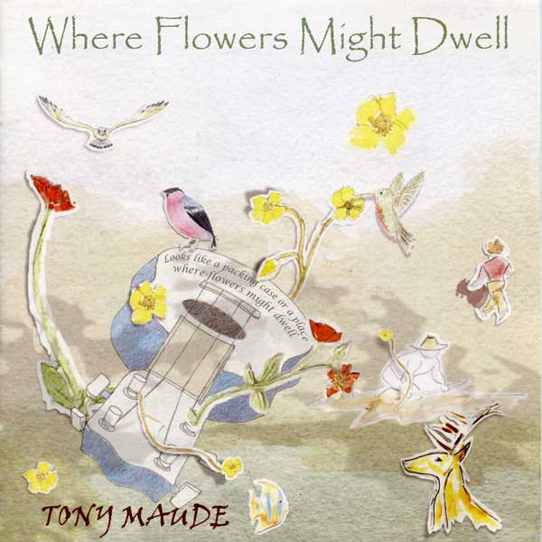
Tony Maude is a composer, poet and singer who combines great literature with sensitive guitar work – sometimes he brings his ukulele, too! – mesmerizing the audience with his wonderful voice.
Bring the whole family along and listen to the hoof beat of the “five and twenty ponies trotting through the dark” in Kipling’s “Smuggler’s Song”, accompany Leary the Lamplighter on his nightly rounds and marvel at Shakespeare’s sonnets turned into music.
Tony Maude has been in theatres, universities, schools, even prisons (and at the American Library!), providing an escape for us into an entertaining and lyrical evening of poetry and song.
“Time and again, reviewers from Donegal to Dusseldorf will try to explain what it is Tony Maude has that can still a noisy bar, draw crowds in the street or communicate to the present with texts that are centuries old.” (Irish News)

Admission free – donations welcome! Please call ahead and reserve a seat! Sign up starts July 2nd.

The American Library will be closed for the summer from August 4th – September 2nd.
We wish our readers a great summer!

Die Amerikanische Bibliothek ist vom 4. August bis 2. September geschlossen.
Wir wünschen unseren Leserinnen und Lesern einen schönen Sommer!

